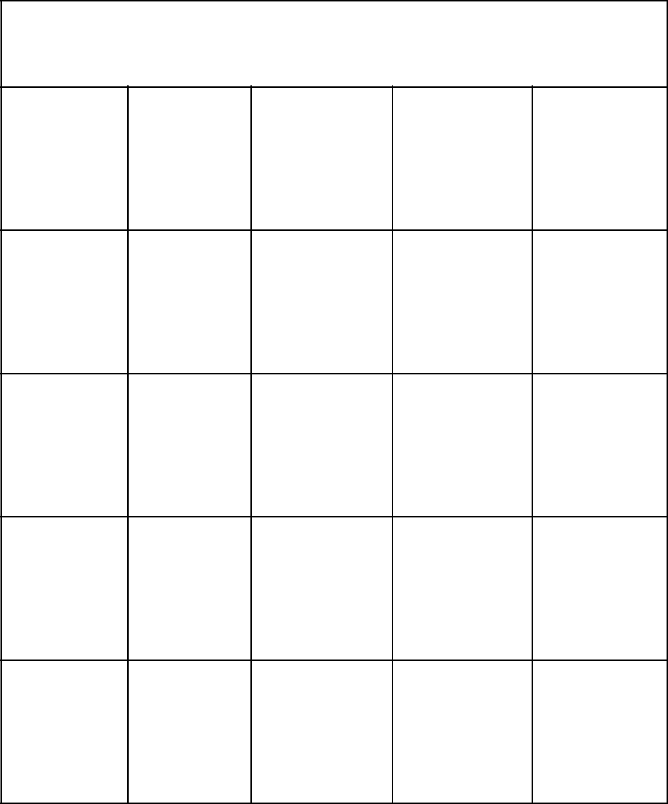**Schechter Experiences Bingo**

|  |  |  |  |  |
| --- | --- | --- | --- | --- |
| Joseph | Musical | B’nai | Chemistry | Who Loves |
| Play |  | Mitzvahs |  | America? |

|  |  |  |  |  |
| --- | --- | --- | --- | --- |
| Gym | Partners | Siddur | Nationalism | Alternative |
|  | with God | Ceremony |  | Israel |

|  |  |  |  |  |  |
| --- | --- | --- | --- | --- | --- |
| Go Lions! | LA | **FREE** | 5th Grade | Wrap and |  |
| **Free Space** | Shabbaton | Strap |  |
|  |  |  |

|  |  |  |  |  |  |
| --- | --- | --- | --- | --- | --- |
| Touching | Kehillah | Yom | Specials | Gathering |  |
| The Lights | Ha’Atzmaut | Blue |  |

|  |  |  |  |  |  |
| --- | --- | --- | --- | --- | --- |
| Soccer | Tribes | Ultimate | The Pizza | Speak |  |
| Team | Frisbee | Eater |  |
|  |  |  |



**Schechter Experiences Bingo**